**Screenshot – Assignment 10 by Venneti Kalyana Chakravarthy**

**Scipy:**

We have the min and max temperatures in a city In India for each months of the year. We would like to find a function to describe this and show it graphically, the dataset given below.

**Task:**

1. Fitting it to the periodic function

2. Plot the fit

**Data:**

Max = 39, 41, 43, 47, 49, 51, 45, 38, 37, 29, 27, 25

Min = 21, 23, 27, 28, 32, 35, 31, 28, 21, 19, 17, 18

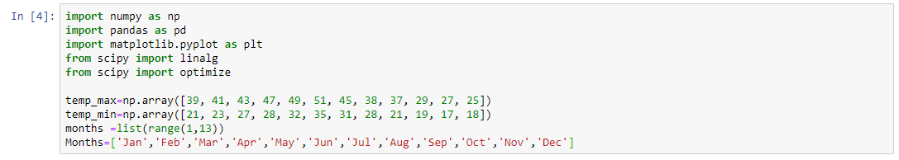

**Question 1:** Fitting it to the periodic function

**Solution:**

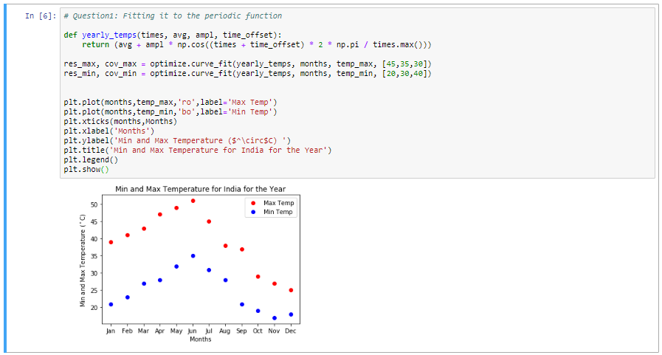

**Question 2:** Plot the fit.

**Solution:**

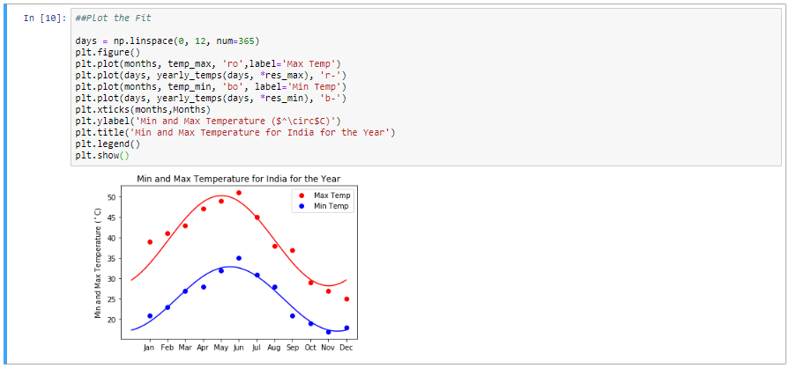

**Matplotlib:**

This assignment is for visualization using matplotlib:

**Data to use**:

**url**=https://raw.githubusercontent.com/Geoyi/Cleaning-Titanic-Data/master/titanic_original.csv

titanic = pd.read_csv(url)

**Charts to plot:**

1. Create a pie chart presenting the male/female proportion

2. Create a scatterplot with the Fare paid and the Age, differ the plot color by gender

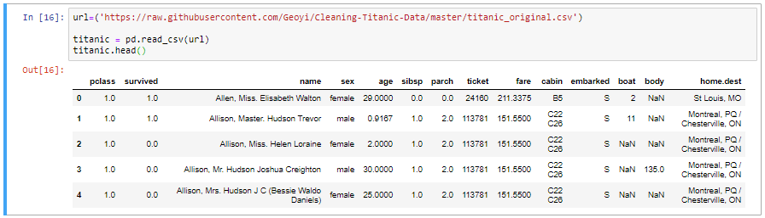

**Question 3:** Create a pie chart presenting the male/female proportion

**Solution:**

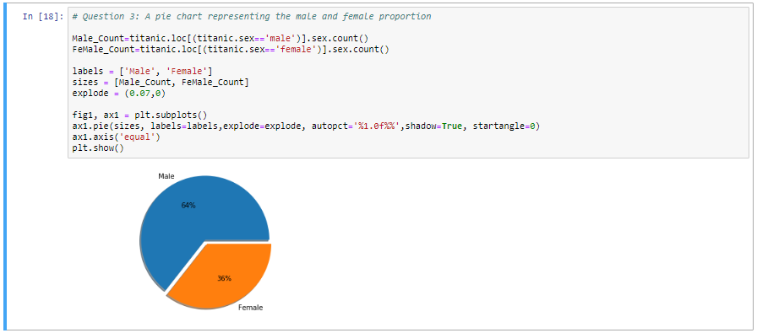

**Question 4:** Create a scatterplot with the Fare paid and the Age, differ the plot color by gender

**Solution:**

